|  |  |  |  |  |
| --- | --- | --- | --- | --- |
| C:\Users\Dell\Desktop\ReactjsInstallation\Automation Studio.png | | |  | Installation guideline on Windows |
|  |
|  |  | |
|  |  |  |
|  |  | |
|  |  | <https://www.linkedin.com/in/pravesh-jha-33013155> |
|  |  | |
|  |  | <Pravesh28@gmail.com> |
|  |  | |
|  |  |  |
|  |  | |  |

## Prerequisite Software

1. Node JS
2. Web server for Chrome Extension

## Host Automation Studio on IIS Step by Step:

1. Download Automation studio from github.
2. Create any folder on your device and place the downloaded folder inside it. Over here I created a folder (AutomationStudio) in My C drive and place the download folder inside it.

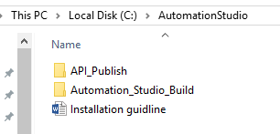

1. Launch Web server for chrome.
2. Select Reports folder (C:\AutomationStudio\Automation_Studio_Build\Automation_Resources\Reports) from Web Server Chrome.

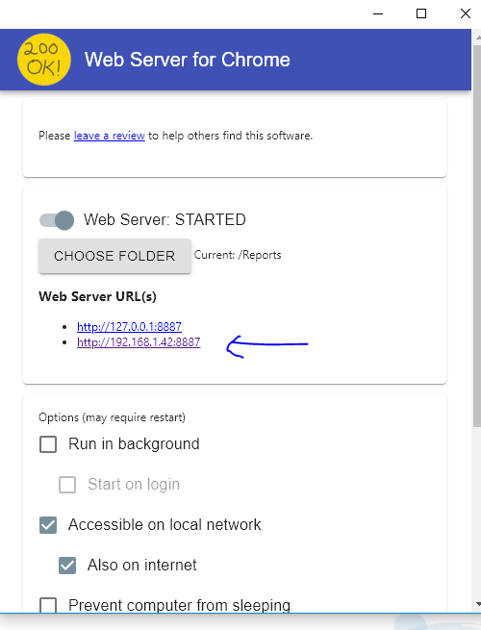

1. Note down Web Server URL (IP)
2. Open Web.config file from C:\AutomationStudio\API_Publish folder.

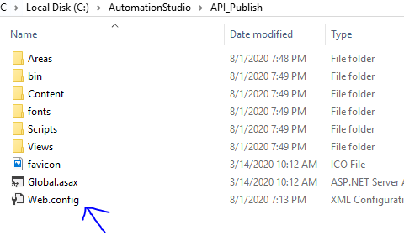

1. Update RectjsDir key with value : (C:\AutomationStudio\Automation_Studio_Build\Automation_Resources\)
2. Update ReportPublishURL key with value (Web server URL)

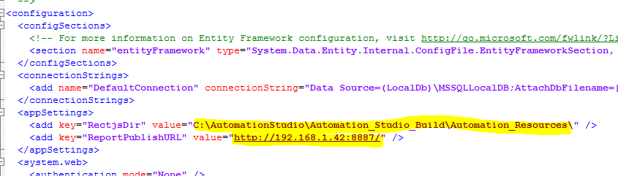

1. Add new Site in IIS (select any name automationstudioapi, port number 49957 and select set Physical path =C:\AutomationStudio\API_Publish

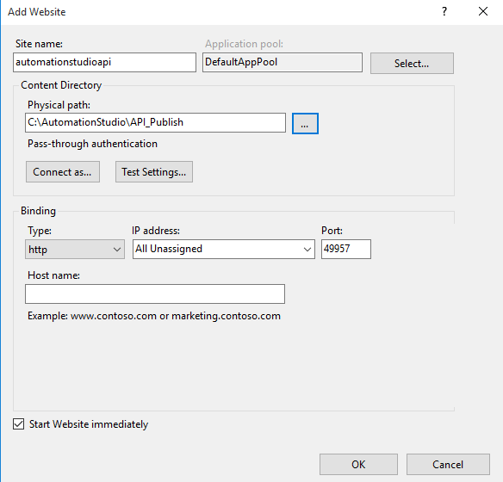

1. Note down API URI : (<http://MachineIPAdrress:49957/>)
2. Open ServerAddress.js file from C:\AutomationStudio\Automation_Studio_Build\build folder.

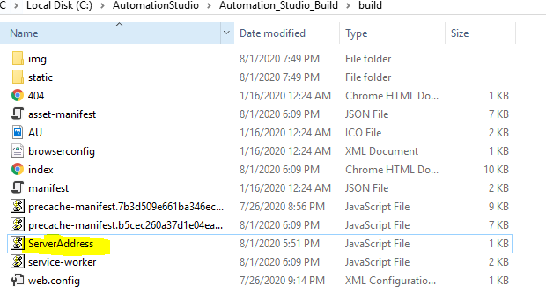

1. Update APIURL : <http://MachineIPAdrress:49957/api/> and ReportURL : IP (web server for chrome)
2. Add new site from IIS (sitename=Automationstudio,Physicalpath= C:\AutomationStudio\Automation_Studio_Build\build , Port Number =3001)

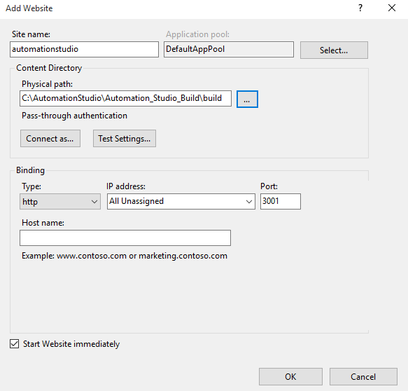

1. Browse your application using IP or local host ☺